5 .Design PDA for input aabbbbc.

DESIGN:

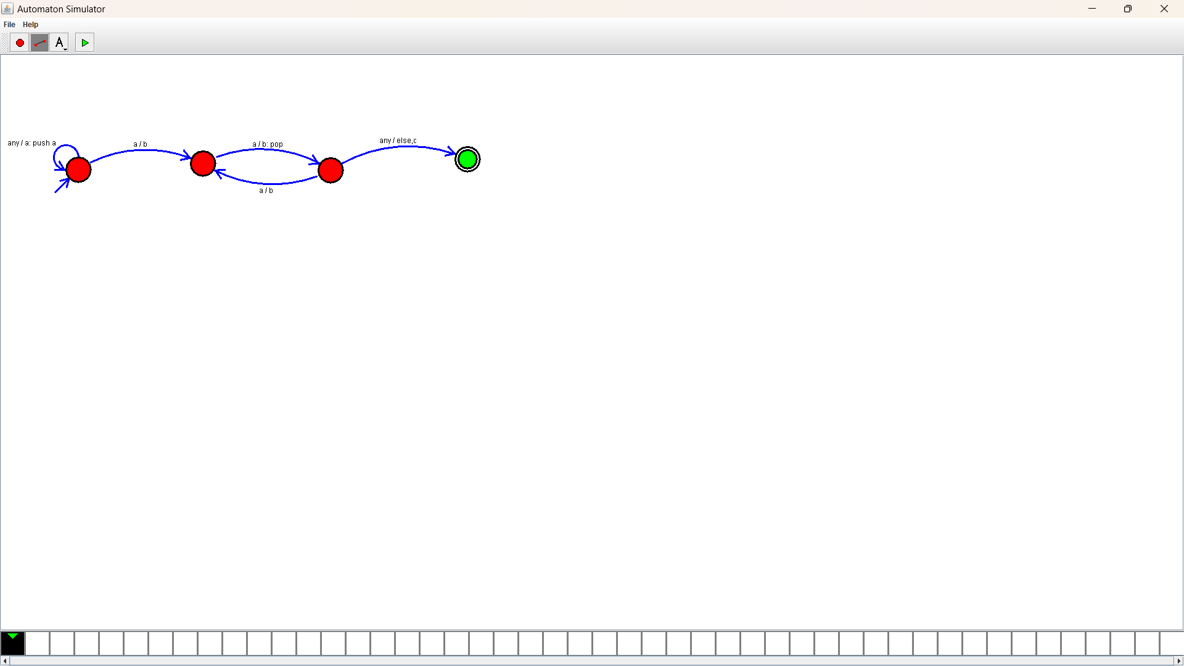

OUTPUT:

